Menstruation and Menopause

Topic for – Paper-PHYG, CC -4 (Reproductive Physiology)

Nadim Haider, Assistant Professor and HOD, Department of Physiology,
Netaji Nagar Day College, Kolkata-700092, West Bengal

Introduction:
Menstrual and menopausal management is a very important subject that needs attention and be perceived from angles such as, gender equality, Water, Sanitation, and Hygiene (WASH), Reproductive health, Education. Girls may avoid attending school and women avoid attending offices during their period due to fear of bullying and inadequate toilet facilities. In the case of discomfort and menstrual pain, they cannot concentrate. In many countries, lack of privacy and inadequate toilet doors or cubicles pose a challenge to girls during their period. The lack of affordable menstrual products can also be a problem.
Your menstrual cycle can tell you a lot about your health. The last thing it should predict is the way you take bath or indulge in social activities. Regular periods mean your body is working normally. So, stop believing in what you have heard until you get any scientific reasons to support it.

Menstruation:
Menstruation (also known as a period) is the regular discharge of blood and mucosal tissue from the inner lining of the uterus through the vagina. It usually starts in a female after attainment of puberty, when the gonads start secreting gonadotrophic hormones. The stage when a female experiences menses for the first time is called Menarche. Menstruation is one of the important stage of the Menstrual cycle.

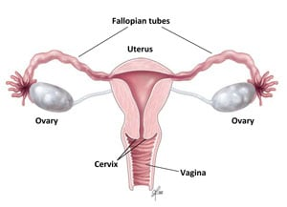
Menstrual cycle:
Menstrual cycle involves a series of natural changes in hormone production and the structures of the uterus and ovaries of the female reproductive system that makes pregnancy possible. The ovarian cycle controls the production and release of eggs and the cyclic release of oestrogen and progesterone. The uterine cycle governs the preparation and maintenance of the lining of the uterus (womb) to receive an embryo. These cycles are repeated every month after an interval of 28 days and are continued in a female upto the age of 30-45 years.
Naturally occurring hormones drive the cycles; the cyclical rise and fall of the follicle stimulating hormone prompts the production and growth of oocytes (immature egg cells). The hormone oestrogen stimulates the uterus lining (endometrium) to thicken to accommodate an embryo if fertilization does occur.
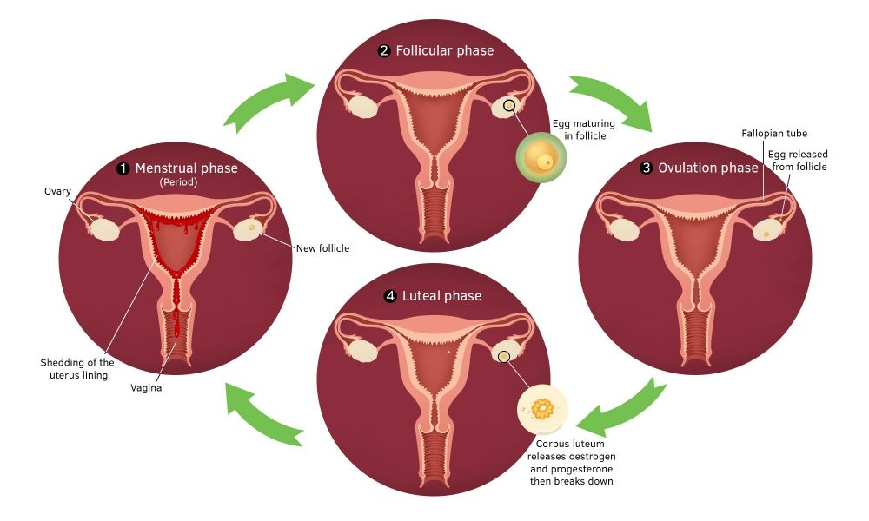

Phases of menstrual cycle:
Menstrual cycle is the cyclic events that occur either in the ovary (ovarian cycle) or in the uterus (uterine cycle). The phases of ovarian cycle includes follicular phase, ovulation, and the luteal phase; the uterine cycle consists of the menstrual, proliferative and secretory phases. Day one of the menstrual cycle is the first day of the period, which lasts for about five days. Menarche (the onset of the first period) usually occurs around the age of twelve years.The premenstrual syndrome developed in the adolescent female includes tender breasts, and tiredness. More severe symptoms that affect daily living are classed as premenstrual dysphoric disorder that includes physical and behavioural symptoms, and are experienced by 3–8% of women. Some women experience period pain that can spread from the abdomen to the back and upper thighs.

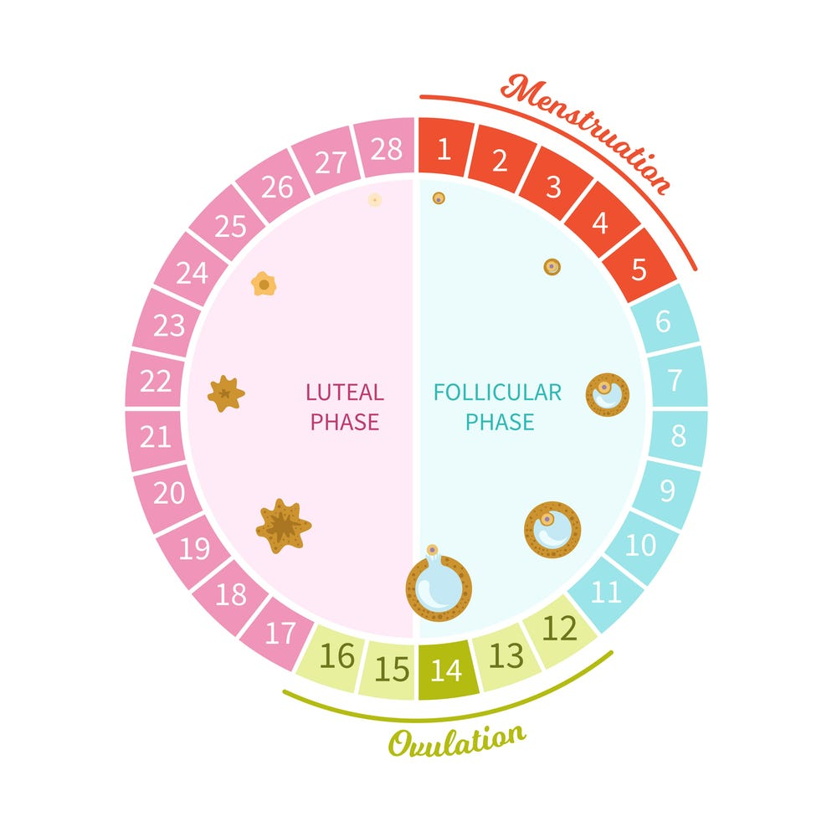

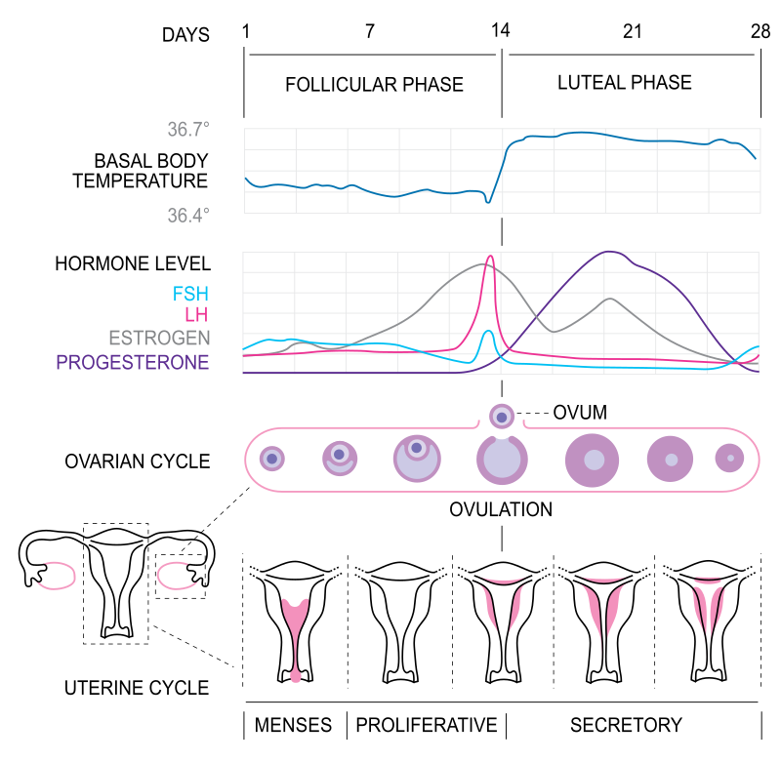

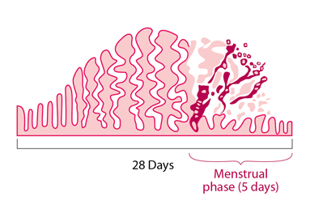
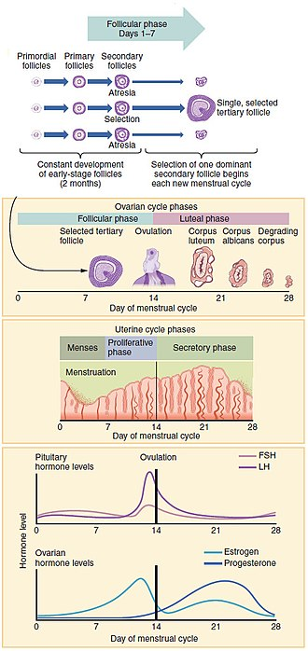
Progression of the menstrual cycle and some of the hormones contributing to it.

Menstrual hygiene management (MHM) and its challenges or menstrual health and hygiene (MHH):
It refers to access to menstrual hygiene products to absorb or collect the flow of blood during menstruation. It can be particularly challenging for girls and women in developing countries, where clean water and toilet facilities are often inadequate. In addition, traditional cultures make it difficult to discuss menstruation openly. This limits women's and adolescent girls’ access to relevant and important information about the normal functions of their own body. This directly affects their health, education, and dignity. Menstrual waste is largely ignored in schools, colleges and in work places in developing countries, despite, it being a significant problem. Menstruation can be a barrier to education for many girls, as a lack of effective sanitary products restricts girls' involvement in educational and social activities. MHM requires a minimum level of knowledge and awareness in women and adolescent girls to manage their menstruation effectively and hygienically by using a clean material to absorb or collect menstrual blood, by practicing good hygiene and personal care during their period, and by having access to facilities to wash or dispose of used menstrual management materials with dignity and in an environmentally responsible manner. Therefore, sufficient knowledge, guidance and support for girls and women in preparation for and during menstruation is also desirable as a part of the life. In India, a majority of girls are at risk for reproductive tract infections (RTI) because of poor MHM.

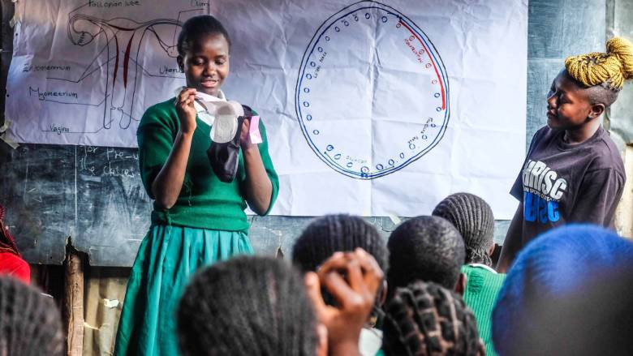

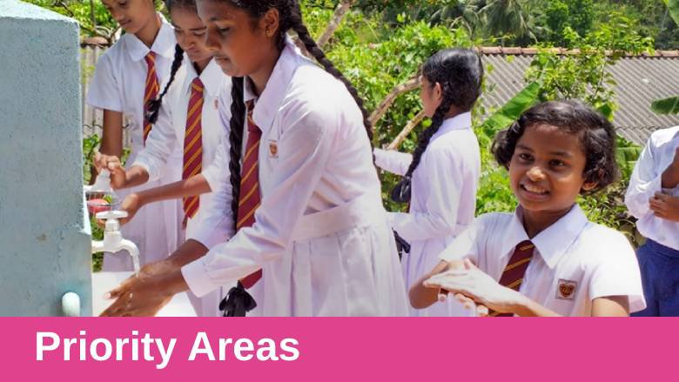

Period poverty:
A term used to describe the lack of access to adequate menstrual hygiene management supplies and education, including sanitary products (e.g., tampons, pads, liners, menstrual cups), washing facilities, and disposal management. Period poverty is a global health issue.The young adolescents specially in the underdeveloped countries uses materials such as mud, leaves, old paper, cotton, or animal skin to manage their periods. The use of such alternate products may cause a serious health problem. Despite known health consequences, period poverty is often overlooked and not discussed due to social and cultural stigmas and taboos. In recent years, governments have actively increased access to affordable sanitary products and changing social norms towards menstruation.

Approaches for improvements:
Menstrual hygiene management game should be developed for school girls that stimulated detailed responses, and diversified participatory activities in group discussions. The board game will ease girls’ discomfort discussing menstruation. Improving MHM requires community-wide attitudinal changes. Involving men in MHM is a key in order to get them to support their wives and daughters. Other organisations have also worked with games and stories to teach MHM, dispel common myths and start conversations. Such games help to create a positive atmosphere around a topic generally associated with shame and embarrassment.
Menstrual Hygiene Day on May 28 creates an occasion for publicizing information about menstrual hygiene management issues in the media as a way to raise awareness, celebrate and normalize menstruation and menstrual hygiene.

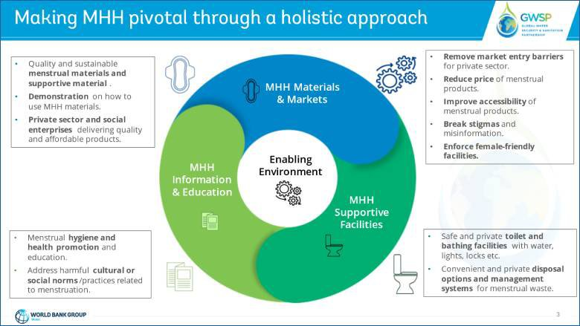

Hygienic practices during menstruation
These hygiene practices can help you stay healthy and comfortable during your period:
- Wear lightweight, breathable clothing (such as cotton underwear). ...
- Change your menstrual products regularly.
- Keep your genital area clean.
- Use unscented toilet paper, tampons, or pads.
- Drink enough liquids.

Menopause:
Menopause is a normal condition in the life of a women. It usually starts after age 40, when a woman’s ovaries no longer release an egg every month and menstruation ceases. It is the end of menstrual cycles in female. It is a point in time 12 months after a woman's last period. The term is sometimes used to describe the changes the female go through just before or after they stop having periods, marking the end of reproductive years. It usually happens around age 40-45 years.

Stages of Menopause:
The different stages of menopause in life of a female is discussed below:
- Pre-menopause: Beginning sometime after age 40, symptoms of perimenopause may come on gradually. In fact, some women may not initially realize that symptoms such as irregular periods, mood swings, sleep troubles, or worsening PMS are ushering her in to menopause.
- Peri-menopause: If a woman has not menstruated in a year, she has transitioned into menopause. She may find an increase in symptoms, such as hot flashes, night sweats, difficulty sleeping, and irritability.
- Post-menopause: In this phase, a woman may feel as if her life is settling back down. Menopause symptoms are diminished or have disappeared, and she may feel an increase in energy.

Symptoms of Menopause:
Vasomotor symptoms are the most common symptoms experienced by menopausal women . The most common is hot flashes during which there is a sudden feeling of warmth that spreads over the upper body, often with blushing, a racing heart, and sweating. Other symptoms of menopause includes uneven or missed periods, vaginal dryness, sore breasts, needing to pee more often, anxiety, changes in mood, trouble sleeping, ,emotional, dry skin, eyes, or mouth, fatigue, depression, crankiness, headaches, joint and muscle aches and pains, weight gain, hair loss, bone loss (osteoporosis), heart disease, higher risk of Alzheimer's disease, more wrinkles, weaker vision, such as cataracts (clouding of the lens of the eye) and macular degeneration (breakdown of the tiny spot in the centre of the retina that is the centre of vision) etc.

Menopause Management:
Menopause is a natural process. Many symptoms will go away over time. Common treatments include the following:

Hormone replacement therapy (HRT). This is also called menopausal hormone therapy. Medications should replace the hormones that your body isn’t making anymore. But they can also put you at higher risk of health problems like heart disease or breast cancer.

Topical hormone therapy. This is an oestrogen cream, insert, or gel that you put in your vagina to help with dryness.

Non-hormone medications. The depression drug paroxetine (Brisdelle, Paxil) is FDA-approved to treat hot flashes.Medicines called selective oestrogen receptor modulators (SERMs) help your body use its oestrogen to treat hot flashes and vaginal dryness.

Medications for osteoporosis. You might take medicines or vitamin D supplements to help keep your bones strong.

Lifestyle changes: changes in lifestyle help the females to deal with the symptoms of menopause.
- If you’re having a vasomotor symptom like hot flashes, drink cold water, sit or sleep near a fan, and dress in layers.
- Use an over-the-counter vaginal moisturizer or lubricant for dryness.
- Exercise regularly to sleep better and prevent conditions like heart disease, diabetes, and osteoporosis.
- Strengthen your pelvic floor muscles with Kegel exercises to prevent bladder leaks.
- Stay socially and mentally active to prevent memory problems.
- Limit how much alcohol you drink, to lower your chance of getting breast cancer and help you sleep better.
- Eat a variety of foods and keep a healthy weight to help with hot flashes.
- Practice things like yoga, deep breathing, or massage to help you relax.

Menopause diet. What you eat might affect when you enter menopause, research suggests, a higher consumption of oily fish was found to delay the timing of natural menopause by approximately 3 years, and fresh legumes -- such as peas and green beans -- was linked to a later menopause by around a year, On the other hand, a higher consumption of refined carbohydrates -- such as pasta and rice -- hastened the onset of menopause by 1.5 years. A high level of circulating insulin could interfere with sex hormone activity and boost oestrogen levels, both of which might increase the number of menstrual cycles and deplete egg supply faster, thus causing an earlier menopause. In vegetarians, menopause starts about one year earlier than non-vegetarians. The high-fibre and low-animal-fat content in some vegetarian meals has been linked to low oestrogen levels.
But meat eaters who ate higher daily amounts of savory foods -- such as potato chips, pretzels, and peanuts -- experienced menopause about 2 years earlier than meat eaters who didn'.

Alternative and Complementary Menopause Treatments: Some studies have found that soy products relieve hot flashes, but researchers are still looking into it.

Women with early menopause:
Women who experience spontaneous or induced menopause faces severe vasomotor symptoms than women reaching menopause at the mean age (51–52 years), and are at higher risk for osteoporosis, and possibly coronary heart and neurodegenerative disease. Use of systemic HT in this patient population, higher than standard doses are often appropriate.

Conclusion:
The women should understand that there are many myths and misconceptions regarding the menstruation and menopause that usually prevail in the society. They should understand that these processes in females are not the abnormal conditions but a natural one that occurs in every female at a certain stage of her life. Females should face it boldly without suffering from any stress and anxiety and should take challenges for smooth, healthy and hygienic management of their menstruation and menopausal periods, expecting a positive response and positive attitudes from the society to lead a healthy and prosperous life.

